
柳明園LIU MING YUAN MEMORIAL DONATION

LEAVE A GREEN LEGACY AT THE CHINA FRIENDSHIP GARDEN

St. Paul-Changsha China Friendship Garden of Whispering Willows & Flowing Waters, Phalen Regional Park in St. Paul, Minnesota

Donate $1,000 or more to dedicate a tree/shrub/flower/plant in honor of or in Memory of a Loved One.
You may choose to have your photo taken with it and your photo will be posted on the MCFGS website.

Donor Name(s): _____________________________________________
NOTE: All individual donors giving $2,000 or more will also recognized as a “BRIDGE BUILDER” on the permanent Donor Wall at the China Garden site. [All donors are listed on MCFGS website.]

In Honor of __________________________________________
My Donation:

$1,000 Tree Memorial

$2,000 (Individuals Donor Wall Category)
$4,000 (Business Donor Wall Category)

Other: $____________
In Memory of __________________________________________

Email: ___________________________________________________
Address: ___________________________________________________
____________________________________________________
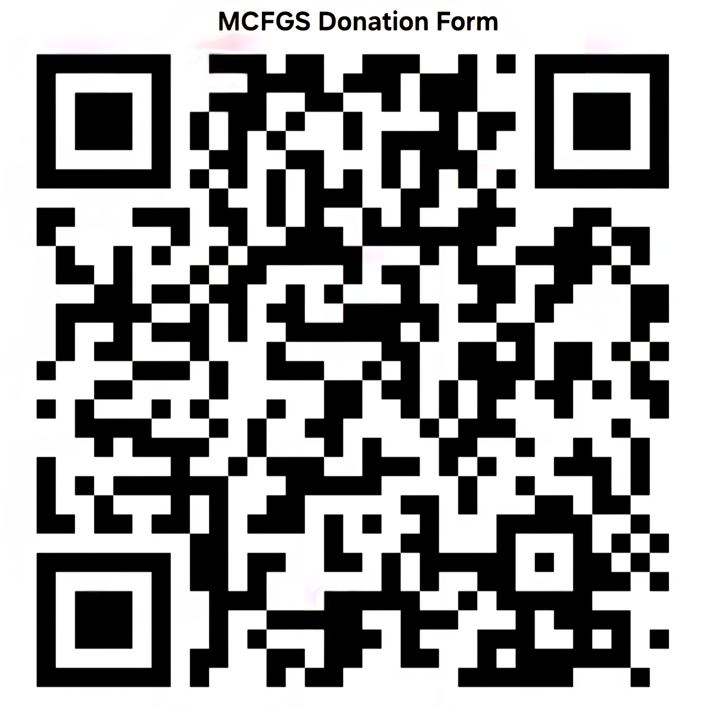
Phone: ____________________________________________________
Employer: _________________________________________________
€ Yes, I would like my photo taken with the Memorial Tree and posted on the website
€ Please mark my donation “Anonymous”
€ Yes, my Employer has an employee matching donation program
€ Please contact me about volunteering


Ways to donate:
- DONATE BY CHECK payable to MN China Friendship Garden Society or MCFGS,
1492 E Shore Drive, St. Paul, MN 55106
- Find other donation options at: https://mnchinagarden.org/make-a-donation/
- SEE ALL TREE MEMORIALS AT THE MCFGS WEBSITE: https://mnchinagarden.org/memorial-trees/

This is a project initiated by the Minnesota China Friendship Garden Society (MCFGS), which is a nonprofit 501(c)(3) organization
(tax ID#20-2838160). Your donation is tax-deductible to the full extent allowed by law.
Interested in Donating or Volunteering? Contact:
The Minnesota China Friendship Garden Society, President Brian Hammer, Saint Paul, MN 55106
Email: mcfgs@mnchinagarden.org | Website: www.MNChinaGarden.org
Follow us on Facebook: Friends of St. Paul-Changsha Friendship Garden at Phalen Park

